

Name _______________________________________________ Date ________________________

West Virginia Births and Deaths
Instructions:
Use the graph below to answer the following questions.
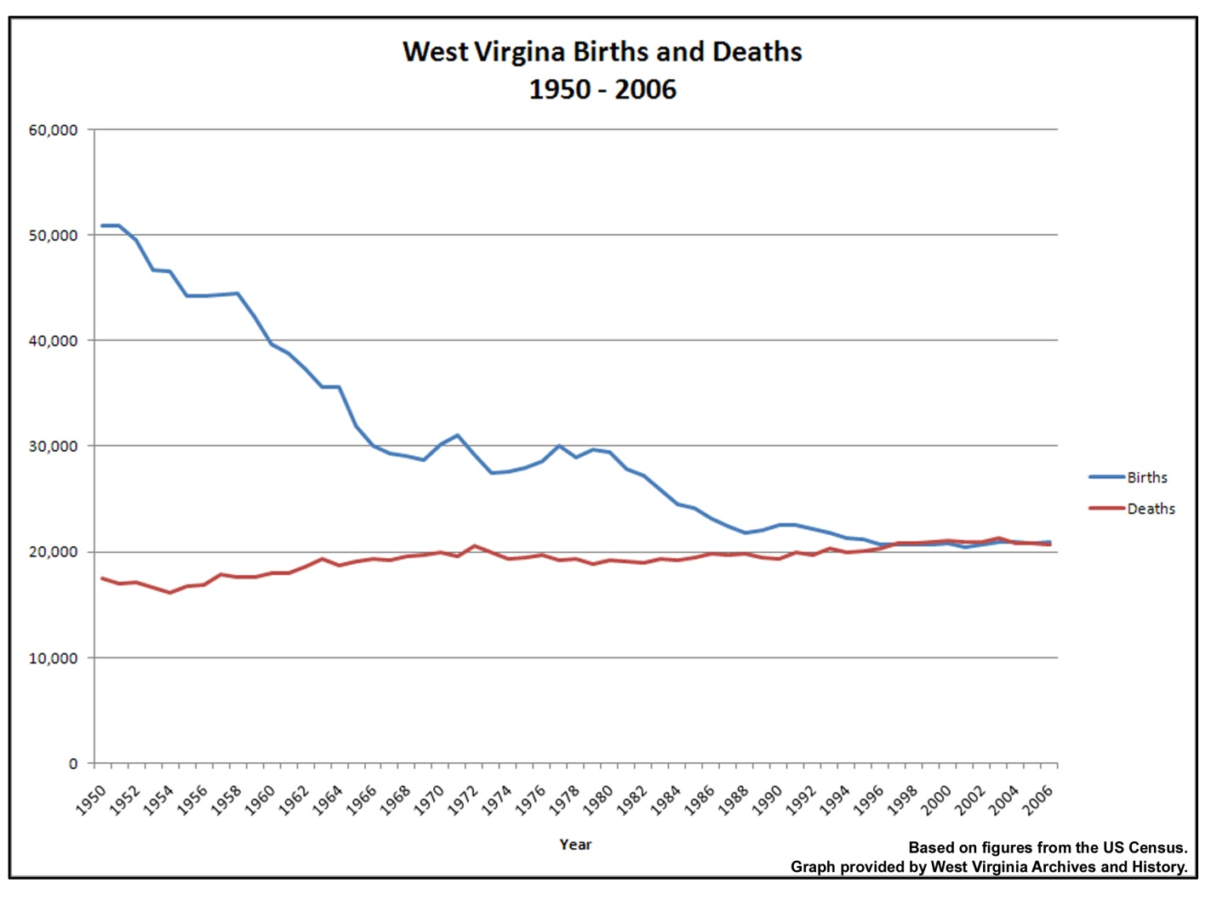
Questions

1. What has happened to the number of births in West Virginia since 1950?

2. What has happened to the number of deaths since 1950?

3. Since 1996, how do births and deaths in West Virginia compare?

