Name _______________________________________________ Date ________________________

West Virginia Primary 1960
Instructions: The following ad was published during the 1960 Democratic Presidential Primary when Massachusetts Senator John F. “Jack” Kennedy ran against Minnesota Senator Hubert Humphrey. Other candidates were hoping that Kennedy would lose the West Virginia Primary and be stopped in his quest to become president. Look at the ad for a full minute before answering the questions below.
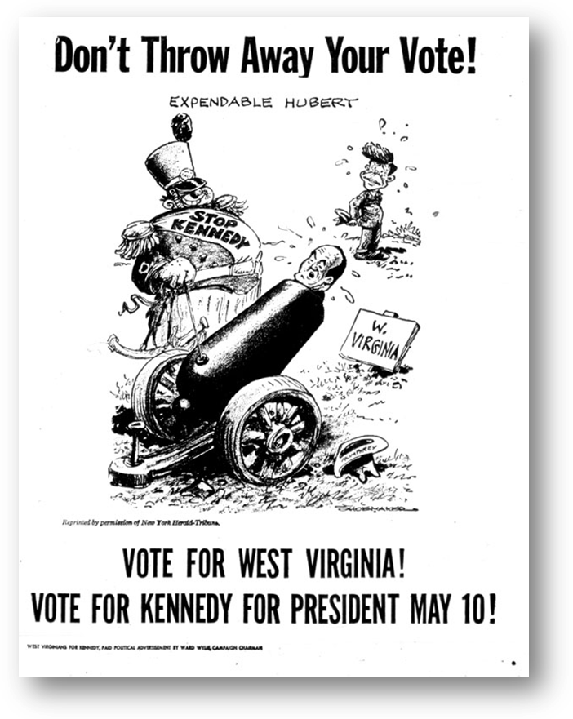
Questions
1. What is headline of this ad?

2. Who is the man in the cannon and what is he being used for?

3. Who does the man in the uniform represent?

4. Who was the target?

5. What was the artist trying to say with this cartoon?

6. What is the entire ad trying to tell voters?
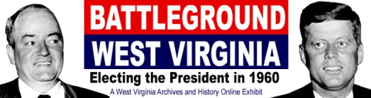
http://www.wvculture.org/history/exhibits.html

