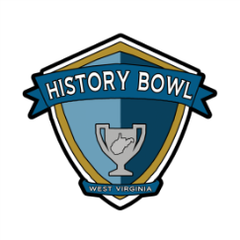
West Virginia History Bowl 2023
Team Application Play-In Tournament
Saturday, March 11, 2023 – Buckhannon-Upshur High School
Application Deadline: February 27, 2023
School Information
School |  |  | County
Address |  |  | Phone
City/State/Zip |  |  | RESA #
Team Information
School Mascot |  |  |  | School Colors
Team Sponsor |  |  |  | Sponsor Email
Sponsor Phone |  |  |  | Sponsor Cell
West Virginia History Bowl Roster
To be eligible students must be enrolled as fulltime students in the participating school or homeschool association.

Note to sponsors: This roster may be a tentative list. Changes or substitutions to the roster can be made at registration on the day of the tournament.

For questions concerning West Virginia History Bowl eligibility contact Royce Diehl at adam.r.diehl@wv.gov.

Player 1
Player 2
Player 3
Player 4

Return a copy of this form to: Royce Diehl, West Virginia History Bowl,
The Culture Center – Building 9, 1900 Kanawha Blvd., East, Charleston, WV 25305.
Forms can also be emailed to adam.r.diehl@wv.gov or faxed to 304-558-4193.
Forms must be postmarked by: February 27, 2023

By signing this document, the participating school, sponsor and team members acknowledge that they meet all eligibility requirements for the West Virginia History Bowl. Failure to do so may result in disqualification of the team and/or school. The participating organization also acknowledges responsibility for travel and all of the travel related expenses.

Sponsor:__________________________________ Date: ___________

Principal: _________________________________ Date: ___________

