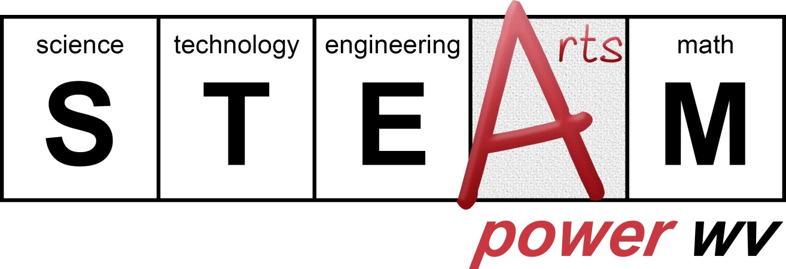
What is STEAM Power WV?
STEAM Power WV is an innovative grant program that supports education initiatives for PK-12 students in West Virginia. Partnering with the Claude Worthington Benedum Foundation, the West Virginia Department of Arts, Culture and History encourages schools, arts organizations, and education non-profits to integrate arts with STEM disciplines in their curriculum and educational programming.

STEAM projects explore the intersections between STEM and the arts, encouraging innovation, creative problem solving, critical thinking, interdisciplinary teamwork and other aptitudes that are critical to 21st Century college and career readiness.

Guidelines and Timeline:
- Eligibility: PK-12 schools (public and private) and organizations holding a 501(c)3 determination letter from the Internal Revenue Service may apply. Educators in the fields of science, technology, engineering and math as well as those involved in the arts are encouraged to develop these projects.
- Applicants may request up to $7,500 to implement a STEAM education project: projects that combine the arts with one or more of the STEM disciplines (science, technology, engineering, and math).
- The application postmark deadline is October 4, 2019. Projects must take place between November 1, 2019 and June 30, 2020.
- Final reports are required for approved projects and due no later than July 21, 2020.

Matching Requirements:
- Required match: applicants may request up to $7,500. A cash match of at least one-third of the total grant award must be provided. (For example: a $7,500 grant requires a match of at least $2,500; a $3,000 grant requires a match of at least $1,000, etc.)

Eligible Activities and Expenses:
- Eligible expenses include contracted artist/professional fees, travel, materials and/or supplies.
- All expenses must relate directly to the proposed project.

Priority will be given to projects that:
- Thoroughly integrate arts and STEM learning activities and objectives
- Include hands-on and problem-solving activities for students
- Encourage collaborations among classroom teachers, teaching artists, and STEM professionals
- Are innovative, creative and collaborative
- Include a strong evaluation component
- Can be documented and are replicable
- Take place in schools
- Take place in underserved areas or among student populations with limited access to STEM and/or arts education projects.

Contact Information:
- If you have questions about applying, or for assistance developing your STEAM project, contact Jim Wolfe at the West Virginia Department of Arts, Culture and History: james.d.wolfe@wv.gov 304-558-0240.

Application Instructions
Project Form
Complete the project form entirely and submit with an original signature. Signature must be from the person who can legally obligate the applicant.
NOTE: Applicant must be the entity receiving the grant payment. If the project takes place at a school, please check with your county board of education to determine whether the grant payment can be made directly to the school or if it should go to the county.
Project objectives must demonstrate what you want participants to know and be able to do at the conclusion of this project. For instance: Arts: Students will know and be able to demonstrate watercolor techniques such as textures and washes. Science: Students will know and be able to identify the parts of flowers by creating detailed illustrations with ink and watercolor.
Project Budget
Expenses: List all anticipated expenses for this project including materials, supplies, fees for artists/experts, travel, etc.
Income: Please indicate source(s) of matching funds and specify whether the match is pending or in hand. Applicants may also list sources of in-kind contributions separately (optional).
Project Narrative
Respond to each question completely. Please limit total project narrative response to no more than three pages.

REQUIRED Support Documents:
IRS 501(c)3 letter (for organizations, not schools)
Taxpayer ID W-9 Form available at www.irs.gov/pub/irs-pdf/fw9.pdf
Complete, sign and date. Provide organization’s or school’s legal name. Address on W-9 form must match address in this grant application. W-9 form is required for payment.
Signed contracts or letters of agreement (for all contracted artist/professional fees)
Documentation of anticipated supplies/materials expenses

OPTIONAL support documents may be attached to your narrative (educational materials such as teaching units, lesson plans, and evaluation tools). Please limit to no more than four documents.

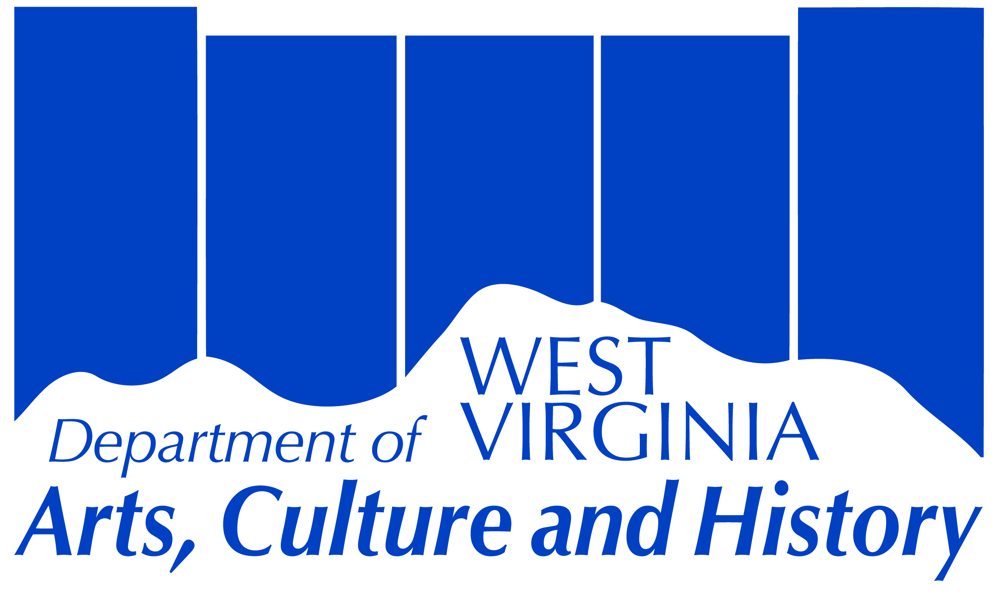
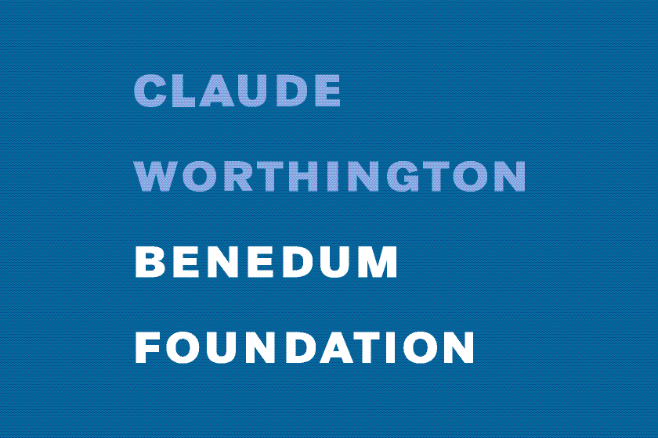
Mail completed application with accompanying documents to:
West Virginia Department of Arts, Culture and History
The Culture Center
Attn: Jim Wolfe, State Arts Office
1900 Kanawha Boulevard, East Charleston, WV 25305
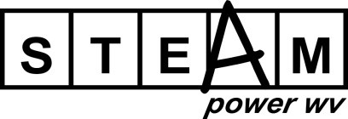
Project Form: Complete this project form and submit with an original signature.

Signature must be from the person who can legally obligate the applicant.

For internal use only
Date Received: _____________
Application #: ______________

Organization/School: |  |  | FEIN:
 |  |  | ##-#######
Contact Person:
Mailing Address (Street or P.O. Box, City, State, and Zip Code): |  | County:
Phone: | Email:
###-###-####
Briefly describe your organization/school – include your mission and goals (limit 500 characters):
Project Name:
Projected number of students participating:
Projected number of teachers participating:
Projected number of Arts/STEM professionals participating:
Briefly summarize your proposed project (limit 500 characters):

Describe the project objectives (what you want people to know and be able to do) in:
Arts
and one or more of the following:
Science
Technology
Engineering
Math

Project Budget:

Expenses for this project
Item | Amount
Total Expenses

Income for this project
Amount
STEAM Power WV grant request:
Cash Match (including source):
Total Income

- Maximum STEAM Power WV grant amount is $7,500.
- Cash match of at least one-third the total grant award must be provided.
- Total Expenses and Total Income should be equal.
- If the project includes in-kind contributions in addition to the required cash match, in-kind may be listed below (optional).

In-Kind Contributions and estimated values (optional)
Item | Amount
Total In-Kind

Signature: Date:

Print Name and Title:

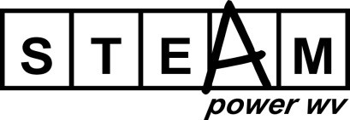
Project Narrative: Answer all questions on no more than three pages total. Responses may be typed directly into the boxes on this form.

1. Who | Who will oversee the project?  □ Include name, title, and qualifications for the Project Leader(s) and other supervisory project partners.
What specific partners or personnel will be involved in the project? Describe the roles of teachers, teaching artists, STEM instructors, guest experts, key committee members, etc.
□ Include name, title, and qualifications for each.
 | What population of students will participate in the project? How will you identify and/or recruit student participants?
2. What | What are the project activities? Describe what will happen sequentially from planning through completion.
3. When | When will this project happen; provide a timeline.
4. Where | Where will this project occur?
5. Why | Why is this project important to your organization, the participants and the community?
6. How | How will you document and share this project with your community?
 | How will you evaluate the effectiveness of the project?
Optional support documents may be attached to your narrative (educational materials such as teaching units/lesson plans, etc.). Please limit to no more than four documents.

Mail completed application with accompanying documents to:
West Virginia Department of Arts, Culture and History
The Culture Center
Attn: Jim Wolfe, Arts Section
1900 Kanawha Boulevard, East
Charleston, WV 25305

