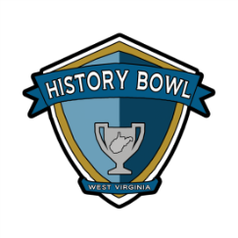
West Virginia History Bowl 2024
Team Application Play-In Tournament
Saturday, March 16, 2024 – Lewis County High School
Application Deadline: March 2, 2024
Please Type All Information
School Information
School |  |  |  | County
Address |  |  |  | Phone
City/State/Zip |  |  |  | RESA #
Team Information
School Mascot |  |  |  | School Colors
Team Sponsor |  |  |  | Sponsor Email
Sponsor Phone |  |  |  | Sponsor Cell
West Virginia History Bowl Roster
To be eligible students must be enrolled as full-time eighth grade students in the participating school or homeschool association.

Note to sponsors: This roster may be a tentative list. Changes or substitutions to the roster can be made at registration on the day of the tournament.

Please Complete a separate form for each team.

For questions concerning West Virginia History Bowl eligibility contact Debra Basham at Debra.A.Basham@wv.gov.
T-Shirt Size
T-Shirt Size
Alternates
Team #

Player 1
Player 2
Player 3
Player 4

Return a copy of this form to: Debra Basham, West Virginia History Bowl,
The Culture Center – Building 9, 1900 Kanawha Blvd., East, Charleston, WV 25305.
Please email forms to Debra.A.Basham@wv.gov
Forms must be postmarked or emailed by: March 2, 2024

By signing this document, the participating school, sponsor and team members acknowledge that they meet all eligibility requirements for the West Virginia History Bowl. Failure to do so may result in disqualification of the team and/or school. The participating organization also acknowledges responsibility for travel and all travel related expenses.

Sponsor:__________________________________ Date: ___________

Principal: _________________________________ Date: ___________

